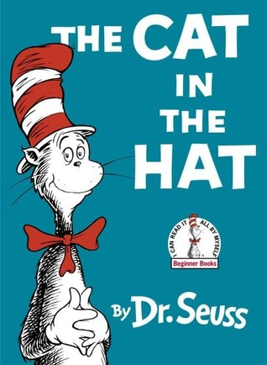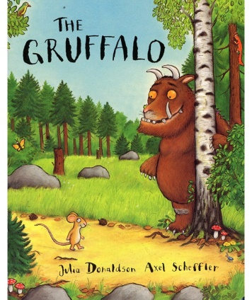

Why not carry on the spirit of world Book Day with your child at home tonight? Snuggle up with them and share their favourite book before bed!

**Year 3**

Children in classes 7&8 had to imagine they had been asked to write a children’s story. They had to write the ‘blurb’ for new book and also design the cover.

Later, they had to design a multi-choice quiz on a book of their choice and also design their own ‘top-trump’ cards for books.

**What we did!**

**World Book Day 2017**

**Reception – classes 1&2**

Today in Reception, the children enjoyed a day learning about children’s author Julia Donaldson.

They explored some of her most popular stories including Room on the Broom, The Gruffalo, Tiddler and

A Squash and a Squeeze.

They also had fun exploring other children’s authors using talking stories.

**Year 1**

World Book Day fun was had by all in Year 1 today.

Firstly, they embarked on a book trail around school to find titles, characters and authors and recorded their findings for later discussion in the classroom.

The children then wrote about their favourite books during Literacy.

Later, as the sun was shining, the children went outside for stories in the gazebo and then went back inside to design book marks.

**Year 2**

The children in classes 5&6 got to choose their favourite book and explain why they like it.

They had to talk about their favourite character in the book.

They then took their book to the Reception class to share it with a younger child.

**Nursery**

**We are celebrating World Book Day in Nursery. The children have requested their favourite book – Pete the Cat.**

**During the morning the children danced and sang the story, used pom-poms to paint shoes and made footprints wearing wellies.**

**It was lots of messy fun!**