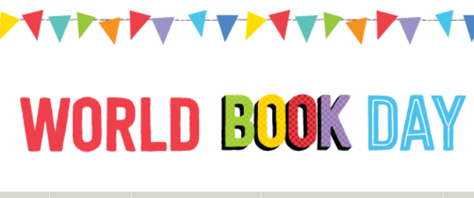

**Year 6**

A very busy day was had by year 6. They began their day with The Balloon Debate – a hot air balloon with a basket containing 7 book titles of our ‘favourite reads’. The children debate and decide which books are to remain in the basket or be replaced by a more popular current read.

They then played the ‘Who am I?’ game. Through a process of elimination, one of the class ask questions that warrant only a ‘yes’ or ‘no’ answer to determine the name of the book character, which is displayed on the crown they are wearing.

Later, each child wrote a book review about a chosen book that they have particularly enjoyed during their time in Year 6.

**Year 5**

Year 5 enjoyed a World Book Day quiz and solved author anagrams.

They created an author and character

board game and later watched authors read extracts from books.

**Year 4 – classes 9 & 10**

Children in classes 9 & 10 had a quiz on Roald Dahl books and tried to solve author anagrams.

They also designed board games around books and designed ‘top-trump’ cards.

Later, they designed a board game around books and authors.