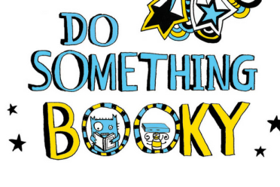**

**World Book Week Focus**

**26th February – 2nd March 2018**

Next week at Firthmoor Primary, the children and staff will be celebrating World Book Week by focusing on various authors and books and also taking part in exciting class activities such as quizzes, puzzle solving and instruction writing. Although we won’t be dressing up for World Book Day, we will be having a wacky hair day in March to support World Autism Week, which is 26th March – 30th March 2018. We will send home further information closer to the time. Meanwhile, please enjoy reading what your children will be doing in school next week for World Book Week.

**Nursery – Mrs Smith**

Nursery will be sharing the book ‘The Egg’ by author M. P. Robertson. The story follows a young boy called George who finds out more than he’d bargained for under his mother’s favourite chicken. When a dragon hatches from the egg, he knows it’s his motherly duty to teach the dragon ‘dragony’ ways!

Over the week, the children will take part in different activities linked to the story. The activities will encourage the children to begin to predict how the story might end and understand the way stories are structured, starting with a strange egg appearing in the Nursery! The children will be encouraged to share their ideas and predictions as to where the egg came from, what might hatch out of the egg and what might happen when it does! The children will also be involved in drama activities to create their own stories to read to the class and making instructions for how to look after a baby dragon.

**Reception – Mrs Graham**

Mrs Graham’s class will be reading ‘Blown Away’ by author Rob Biddulph.

The story is about a brave young penguin who takes a kite flight to a tropical paradise and has to solve the problem of getting back home.

The children will be listening out for rhyming words in the story and then finding further rhyming words of their own.

The will also write a postcard from the tropical island to their family back home.

**Reception – Mrs Dannatt**

Mrs Dannatt’s class will be reading the book ‘Hello from Nowhere’ by author Raewyn Caisley, an Australian author who is a friend of Mrs Dannatt! The story is about a little girl called Eve who lives in a roadhouse in the middle of Nullarbor. When her Nan finally visits one day, Eve shows her all the things that are special about where she lives.

Our focus activities will involve the children writing a postcard to their own family member with an opportunity for them to post it. Whilst sharing the story, we will be looking out for ‘tricky’ words such as an, her, with, his, on, off, to and have. We will also email and hopefully video link with the author directly to talk about the story.

**Year 1 – Mrs Coad**

Mrs Coad’s class will be reading ‘That Rabbit belongs to Emily Brown’ by authors Cressida Cowell and Neal Layton. The story is about a little girl called Emily Brown and her old, grey rabbit called Stanley. One day, the Queen sent her chief footman to swap Stanley for a brand new golden teddy bear. When Emily tells him that Stanley is not for sale, the naughty Queen sends all sorts of different people to her house to try to buy him with lots of different toys. Emily Brown sets out to teach the naughty Queen a valuable lesson!

We will be looking at the various different settings that Emily imagines herself to be in and finding out more about them. The children will be designing a different setting that Emily might imagine herself to be in and write a description of it. We will imagine who might come to our setting and try to take Stanley.

In addition to this, we will create lots of artwork based on the different settings and landscapes throughout the story.

**Year 1 – Miss Trumper**

Miss Trumper’s class will be travelling on an inspiring and creative journey through the wonderful rhyming stories of

Dr. Seuss.

Starting with ‘Oh, the Places You’ll Go’, the children will write about where they would like to go and who/what they will take with them on their travels. After that, they’ll read ‘What Pet Should I Get?’ and this will be a lovely introduction to writing instructions on how to look after a pet.

Other Dr. Seuss stories we will read include ‘The Cat in the Hat’ and ‘Green Eggs and Ham’. These unique stories will entertain the children and stimulate their imagination for some fun, creative writing to follow.

**Year 2 – Miss Jamieson & Miss Heslop**

Year 2 will be reading ‘Little Red Reading Hood’ by author Lucy Rowland. The story is about when Little Red Reading Hood meets a cunning wolf on her way to the library and he persuades her to stray from the path. She thinks it’s time they came up with a new ending for the story. An inspiring take on the classic fairy tale, Little Red Riding Hood, the story celebrates the wonder and magic of stories. During the reading week, we are going to be solving riddles to work out where Little Red Reading Hood has been reading, become book detectives in our school library, consider how Little Red Reading Hood feels when she becomes immersed in a book and how we feel when reading famous lines from books. We are going to continue to use our detective skills to identify the title and author of familiar stories when given sentences from different texts and when hunting for common exception words.

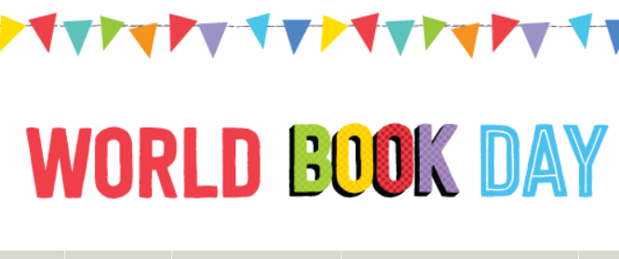

**Spot Prizes**

Daily spot prizes will be awarded throughout the week for completed home/school reading records and reading activities.

**Year 6 – Miss Murray**

Year 6 will be studying ‘Walkabout’ by author James Vance Marshall. The text is about a young girl and her brother who survive a plane crash in the Australian outback.

They meet an Aboriginal boy who helps them to find food and water before tragedy strikes.

As part of World Book Week, the children will take part in a speaking and listening activity where they have to decide on the best equipment to have with them if they were ever stranded somewhere away from civilisation.

As well as this, the children will write a transcript of a news report plea from parents in search of their missing children.

**Year 5/6 – Mr Jefferies & Mrs Walker**

Year 5 and 6 children in these two classes will be looking at the ‘Wallbook Timeline of Sport’from the ‘What on Earth?’ series, which presents information in timeline and newspaper format.

To develop their non-fiction reading skills, children will have the opportunity to write an interview with an historic sporting figure and contribute their own newspaper article based on one of the events from this year’s Winter Olympics.

Other fun activities will include creating their own multi-choice sports quiz and word-based puzzles to develop their vocabulary and sports knowledge.

**Year 3/4 – Miss True & Mrs Blagg**

These two classes will be reading ‘The 13 Storey Treehouse’ by author Andy Griffiths. It’s about two boys called Andy and Terry who live in a 13-storey treehouse. It’s got a giant catapult, a secret underground laboratory, a tank of man-eating sharks and a marshmallow machine that follows you around and shoots marshmallows into your mouth whenever you’re hungry!

The two boys invent things and write stories - Andy does the writing and Terry does the drawings.

We will be writing instructions on how to build a treehouse and thinking of a new room to have in the treehouse.

**Year 3/4 – Miss Lambell & Mrs Irwin**

During book week, these two classes are going to read the book ‘Leon and the place between’ by author Angela McAllister. The book is full of glorious language that will really engage the children and encourage them to extend their vocabulary to dizzy heights! Along with the beautiful writing, the book also has wonderful pictures throughout and is illustrated by Graeme Baker-Smith who really brings the book to life!

The two classes will look at alternative beginnings to the story – ‘What do they predict is behind the purple curtain?’ We will think of lots of interesting and exciting possibilities using a variety of describing words and sentence openers. The children will also imagine that they are a show critic and write a no-nonsense review of Abdul Kazam’s magic show!

Using spectacular illustrations, the children will also design their own show reel to re-tell the story in all its glory!