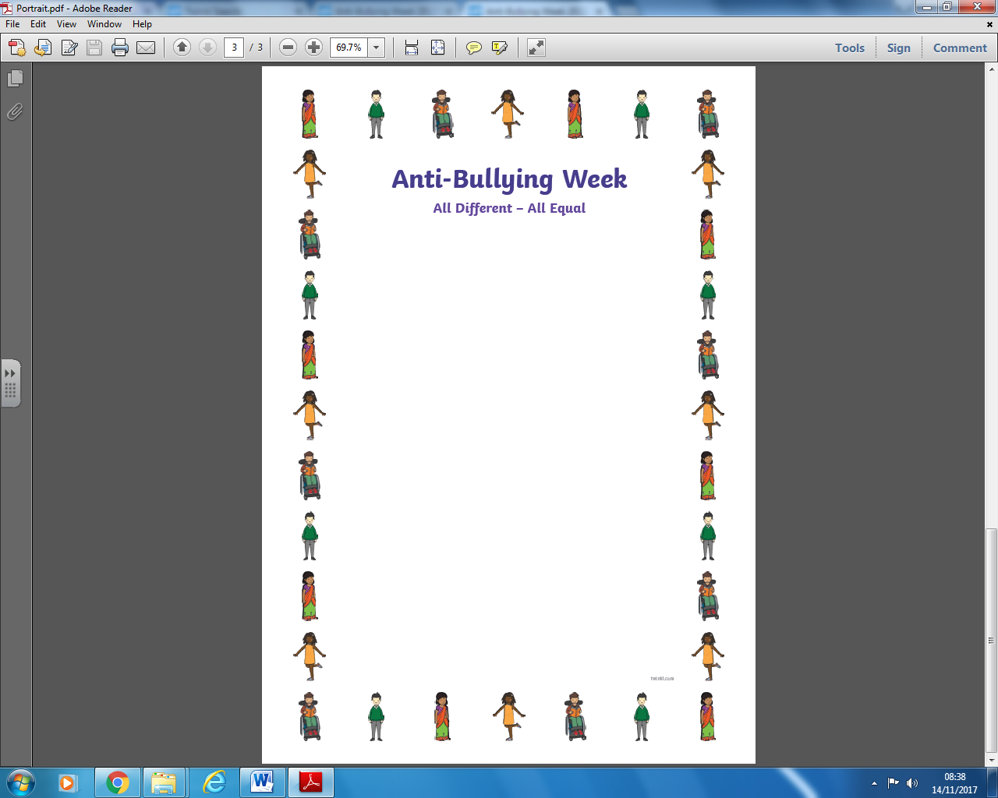

**YRSG/ED ‘The Smartest Giant in Town’ book Friendship Games**

**Y1WC ‘Giraffes can’t dance’ book Kindness**

**Y1VM ‘Is it because’ book Jealousy**

**Y2TH/LJ ‘What’s a Penguin to think How are you**

**when he wakes up pink!’ book different?**

**Y3HL ‘The Sneetches’ book We should treat**

**everyone fairly, despite our differences**

**Y3/4SB ‘We’re all wonders’ book Kindness, what**

**makes me wonderful?**

**Y3/4HI ‘How are you feeling today?’ book How to be a good friend**

**Y4MT ‘Bullying or not’ scenarios Sticks and stones**

**Paper heart activity**

**Y5PJ Body image All different, all equal**

**Y5/6 Debate cards/group work Prepare presentation**

**AW/DM on a particular anti-bullying theme**

**AW/DM**