Firthmoor Primary School
Ingleby Moor Crescent, Darlington, DL1 4RW
Tel: 01325 244001 ● Fax: 01325 244555
Email : admin@firthmoor.darlington.sch.uk
Website : http://www.firthmoor.darlington.sch.uk

Headteacher – Mrs A Dixon



4th September 2019

Dear Parent/Carer

Re; New style reading records for Key Stage 2

Today, your child has been issued with one of our new style reading records.

They may take them home as and when they wish, but children, parents and teachers are only to record and make comments when a book has been finished, before choosing a new book to read.

If children are worried they could misplace the reading record, they may choose to keep it in school during the week and only take it home at the weekend.

- Children should record the book they have read when it is finished and write a short review about it.
- They may choose to write about what they enjoyed about the book or how they felt about the main characters.
- They may also choose to comment on what they didn’t enjoy about the book or how they would’ve preferred the story to unfold.
- Children must share their thoughts about each book read with a parent or teacher, who can then also make a short comment below the child’s book review.

If you are unsure about any of this information, your child’s class teacher will discuss it further at the upcoming parents evening on 18th September (further information to follow).

KS1 children will also be provided with a new reading record very soon, and again parents will be informed about how to use these at the parents’ evening scheduled for 25th September.

Yours faithfully

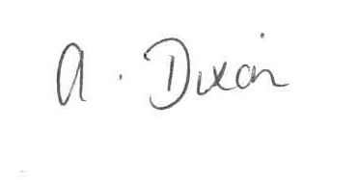
A Dixon
Headteacher

