 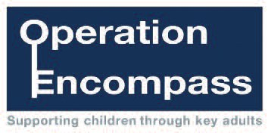

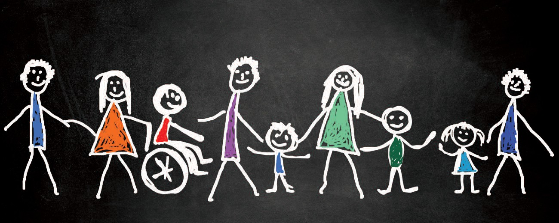

Operation Encompass

**Darlington**

**Operational Protocol**

 

Background 3

What is Operation Encompass? 4

Procedure 5

Police responsibilities 6

Encompass Link Worker in CAP responsibilities 7

School Key Adult responsibilities 8

Support given to children 9

The basis for sharing information 10

Governance & accountability 11

Appendices

Appendix 1 - Definition of domestic abuse 12

Appendix 2 - Support given to children 13

Appendix 3 - Example Encompass Information Log 14

Appendix 4 - Encompass Process Chart 15

**Background**

Purpose

This Operational Protocol outlines how agencies in Darlington will work together to enable schools to provide reactive emotional and practical support within the school environment, to children and young people who witness domestic abuse in the home.

Operation Encompass was launched in Plymouth in February 2011, to address shortcomings in the early sharing of information with schools. Since then Encompass has been rolled out across a number of areas in the UK with successful implementation and positive outcomes for many children and young people. The scheme was rolled out across Darlington to schools and academies from January 2017.

During 2015/16 there were 12,046 incidents of domestic abuse reported to the Durham Constabulary. National research shows that 90% of cases of domestic abuse have children present in the household at the time of the incident. Witnessing domestic abuse has a significant effect on children. Many children do cope with and survive abuse, displaying extraordinary resilience. But witnessing or experiencing domestic violence represents a serious risk to children in our society. The stress of living in a household where domestic abuse is a feature can lead to: withdrawal; aggression or bullying; tantrums; vandalism; problems in school, truancy, speech problems, difficulties with learning; attention seeking; nightmares or insomnia; bed-wetting; anxiety, depression, fear of abandonment; feelings of inferiority; drug or alcohol abuse; eating disorders.

**What is Operation Encompass?**

Operation Encompass provides a method of sharing information between the Police and local schools. This provides the designated Key Adult within the school with information where a child has been present in a household where an incident of domestic abuse has been recorded. The information is aimed to be shared with the school prior to the commencement of the next school day so that the school can provide reactive support within the school environment for that pupil on that day.

Operation Encompass does not replace or supersede existing safeguarding protocols that are in place, existing safeguarding procedures and guidelines continue. A referral will be made to

Children’s Access Point from the police when they attend any incident where a child is involved. Operation Encompass is not about asking the school to do any more than provide immediate support to the child whilst in attendance at school following an incident in the home. It is designed to reinforce safeguarding and ensure children’s wellbeing is of paramount importance.

In Darlington each school has to opt into the Encompass scheme in order to receive Encompass notifications.

By sharing information through Operation Encompass it is hoped that children of school age who are witnessing domestic abuse at home will have access to responsive emotional health and wellbeing support within school after an incident. Schools will receive information all year round when:

* Police have attended a domestic abuse incident.
* The child is present in the household at the time of the incident, either in the same or a separate room.
* The child is of school age (between 4-16 years).
* The incident has been assessed to be standard, medium or high risk incident of domestic abuse.

**Procedure**

* Police attend incident and capture relevant information including names, date of birth, home address, schools attended of any children residing/present in the house. They will include in their sequel to Comms – ‘TAG FOR OP ENCOMPASS’.
* The Dispatcher will tag the incident ‘Encompass’ based on the sequel that they receive.

This will automatically generate an email containing the relevant information which will go to the designated CAP Worker based in the Children’s Access Point.

* The CAP worker on receiving the email shall search for the relevant Safeguarding Domestic Abuse Report which the officer in charge shall have completed by their end of their shift.
* The appropriate School Key Adult will be identified by the CAP Worker through the database of School Key Adults and the relevant information will be shared to safeguard the child.
* The School Key Adult will be informed of the time, date, location of the incident, the parties involved in the incident (including their relationship with the child) and the child’s involvement, i.e. asleep in another room, in the same room, etc. Incidents occurring on a Fri/Sat/Sun will be shared with the School Key Adult on a Monday morning. Each Encompass notification will be given a unique reference number.
* The CAP Worker will maintain a record of the incident number, school and the name of the School Key Adult that the information has been shared with.
* The School Key Adult will receive the information and develop a programme of support for the child within the school based on the information provided and the needs of the child.
* The School Key Adult will update the Encompass information record held by the school.

**Police responsibilities**

Durham Constabulary will attend the incident and record relevant information, including name of children, dates of birth, school attended. The responding officer will include in the sequel ‘TAG FOR ENCOMPASS’ where the incident fits Encompass criteria.

The attending officer will then send the sequel through to Police Comms prior to the end of their shift. This will be before 7 am the next working day.

The Dispatcher who receives the sequel will tag the incident ‘ENCOMPASS’ based on the information provided by the attending officer, this will auto- generate a secure email to the Childrens Access Point via their secure police email account. The secure email will include a copy of the incident log. The email will be generated on closure of the incident.

**Link Worker in Children’s Access Point (CAP) responsibilities**

The CAP Worker in Children’s Access Point will access the police emails before 9am each day. The CAP worker will access Capita One to cross check school information provided by the attending police officer.

The CAP Worker records information for each case which fits Encompass Criteria onto the Encompass.

The CAP Worker searches the School Key Adult database and identifies the schools Key Worker at the respective school, and emails them an operation encompass report prior to 11am and records time and date that the notification was sent.

**School Key Adult responsibilities**

The school should ensure that a Key Adult is identified within the school. This is usually the Designated Child Protection Officer/Safeguarding Lead, Head Teacher or member of Senior Leadership Team, with a relevant deputy and that these contacts are kept up to date with the Encompass Childrens Access Point Worker.

The designated Key Adult will have undertaken Child Protection training.

Schools should record the information that they receive on an appropriate digital data base. An example of information that should be stored is provided at Appendix 3. The information should be stored in such a way that is easily available for disclosure in the event of a serious case review or domestic homicide. The school should provide feedback to the CAP on the outcome of the sharing of information when requested.

The school should note that the Police reported incident that triggered the Operation Encompass notification will have already been referred into children’s social care for assessment in every instance and the school should not make a duplicate referral in relation to the notification.

The designated Key Adult will access the Encompass email to check for any referrals from the Link Worker before 9am and again before 11am each day. If the designated Key Adult will be unavailable then they should arrange for a deputy to access the email.

The Key Adult will ensure that details are recorded within the digital database held by the school and that relevant information is held within the schools child protection files.

On receiving the information the Key Adult will determine how best to accommodate the child throughout the school day to lessen the impact based on the information shared.

**Support given to children**

The Key Adult will determine the most suitable form of support for the child and this can be either overt or silent.

Examples of support that might be offered include:

* Monitor children at the start of the day, monitor their attendance and acknowledge what they have been through.
* Help the child make sense of the way they are feeling and behaving.
* Following an incident, schools may provide suitable clothing (i.e. PE kit) and food.
* Schools may make allowances for the child not being able to engage fully in the day at school, both emotionally and physically
* Arrange for additional support to be made available for the child within school
* Help the child to develop coping strategies.
* Schools may apply for exceptional circumstances to exam boards.

**Appendix 2** provides examples of both silent and overt support that may be offered.

Support should be given based on the individual practical and emotional needs of each child. The School Key Adult should decide the best course of support based on their professional judgment. If required, further advice can be provided by the CAP Operation Encompass Worker.

**The basis for information sharing**

There are a range of information and sharing processes and protocols in place that permits the sharing of information under Operation Encompass - specifically in relation to the Children’s Act 2004 and Crime and Disorder Act 1998:

* Children’s Act 2004 - Sections 10 and 11
* Crime and Disorder Act 1998
* Working together to safeguard children statutory guidance
* Local Safeguarding Children’s Board - Policies and Procedures
* Education Act 2002

Operation Encompass information will be shared by means that are proportionate, legal, accountable and necessary, therefore upholding human rights and ensuring data protection legislation is adhered to.

**Governance and accountability**

Operation Encompass reports into the Darlington Safeguarding Partnership.

An Operation Encompass Steering Group has been established to bring together relevant Partners from services with the remit of implementing Operation Encompass across Darlington, led by Darlington Borough Council.

**Appendix 1 – Definition of domestic abuse**

***any incident or pattern of incidents of controlling, coercive or threatening behaviour, violence or abuse between those aged 16 or over who have been intimate partners or family members regardless of gender or sexuality. This can encompass but is not limited to, the following types of abuse:***

* + ***psychological***
  + ***physical***
  + ***sexual***
  + ***financial***
  + ***emotional***

This definition also includes so called ‘honour’ based violence, forced marriage and female genital mutilation (FGM), and is clear that victims are not confined to any one gender or ethnic group.

**Appendix 2 – Support given to children**

The two main types of support given to children by School Key Adults have been labelled as ‘silent support’ and ‘overt support’.

**Overt support**

* Meeting physical needs, i.e. breakfast, lunch, provision of school uniform
* 1:1 support such as Learning Mentor, etc.
* Working elsewhere or doing a different activity/ not working at all
* School Buddy
* Making changes to school routine
* Letting the child know you are aware but no-one else
* Assessment of health/emotional wellbeing

**Silent support**

* Make them know who they can talk to if needed
* Lenience to school rules
* Different expectations in relation to their behaviour and work output
* Inform class teacher with minimal information
* Checking collection arrangements at end of school day
* Having staff presence as a form of support throughout the day
* Where appropriate, a discussion should take place with school staff to highlight any other relevant or related issues, i.e. self-harm, non-attendance, etc.

**Appendix 3 – Example Encompass information record**

The form is available in Excel format to ensure capturing of electronic information.

|  |  |
| --- | --- |
| **Encompass Information Log** | |
| Encompass Reference Number: |  |
| Date received at school: |  |
| Child’s name and date of birth: |  |
| Date and time of incident: |  |
| Circumstances of incident: | Nature of domestic incident: physical / verbal abuse  There has been a domestic incident between ……………. and ………………. on …………………….  This has been graded as high/medium/standard risk  Police information states that ……………(child’s name) was / was not seen or spoken to by police. |
| School to complete sections below: | |
| Actions taken and impact: |  |

**Appendix 4 – Encompass Process chart**



Incident occurs which fits Encompass criteria



Police attend and capture relevant information - name, DoB, home address, school attended



Attending officer sends sequel to Comms prior to end of shift



Dispatcher tags Encompass based on sequel



Dispatcher auto-generates an email to Encompass CAP Worker providing basic details of incident



Auto-email is received by CAP Worker prior to 9.00am



CAP Worker searches Domestic Abuse Report and quality checks incident to confirm Encompass



CAP Worker records information on Encompass database and generates unique Encompass reference no



CAP worker searches school Key Adult database and identifies email details and contact



CAP Worker emails school Key Adult



school Key Adult to check for any notification prior to 9am and 11am



If notification received, School Key Adult identifies child and develops a plan of support for that school day taking into consideration the details of the incident and the needs of the child. The Key Adult can refer to the

Operation Encompass Operational Protocol for suggestions on how a child may be supported



School Key Adult notifies additional school staff if appropriate to ensure child is supported

within the school



Key Adult records Encompass notification received using encompass information record which includes

The unique Encompass record number generated by the CAP Worker.



The child is supported within the school by the School Key Adult