Firthmoor Primary School
Ingleby Moor Crescent, Darlington, DL1 4RW
Tel: 01325 244001 ● Fax: 01325 244555
Email: admin@firthmoor.darlington.sch.uk
Website: http://www.firthmoor.darlington.sch.uk

Headteacher – Mrs A Dixon

Dear parent/carer,

We are at the time of year again, as we approach the Winter season, that we need to protect ourselves against seasonal bugs such as colds and flu.

With this in mind, we will be having a visit from the school nursing team in November, who, with your consent, will vaccinate your child using a completely pain-free nasal spray.

To give this consent, please log on to www.hdft.nhs.uk/electronic-consent no later than Monday 2nd November 2020. You will need to enter our unique school code, which is 138129, and then complete a short consent form.

Please note – if you do not provide your consent, your child WILL NOT be vaccinated on the day.

If you need any help, please call Mr Cody directly at the school on 01325 345980, or by email at l.cody@firthmoor.darlington.sch.uk

Yours faithfully

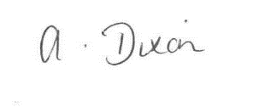
A Dixon
Headteacher

