Firthmoor Primary School
Ingleby Moor Crescent, Darlington, DL1 4RW
Tel: 01325 244001 ● Fax: 01325 244555
Email : admin@firthmoor.darlington.sch.uk
Website : http://www.firthmoor.darlington.sch.uk

Headteacher – Mrs A Dixon

Dear parents/carers,

We would like to notify you that our school photographers will be in school on the morning of Wednesday 7th October.

Unfortunately, this year, due to Covid-19 restrictions, they will not be offering family group sittings or sibling shoots. They will take one photo of each individual child in school on the day and you will be provided a proof of the photo - please note you are under no obligation to buy it.

However, if you would like to purchase the photograph, they need to be ordered and paid for online and full instructions on how to do this will be printed on the proof.

Yours faithfully

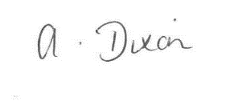

A Dixon
Headteacher

